**ASE LAB Assignment 7 Report**

**Web-Ionic main page screen shot:**

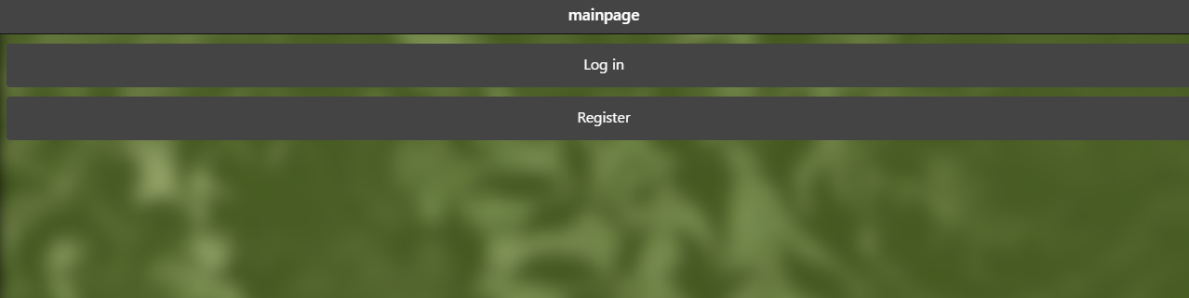

**Web-Ionic Login page screen shot:**

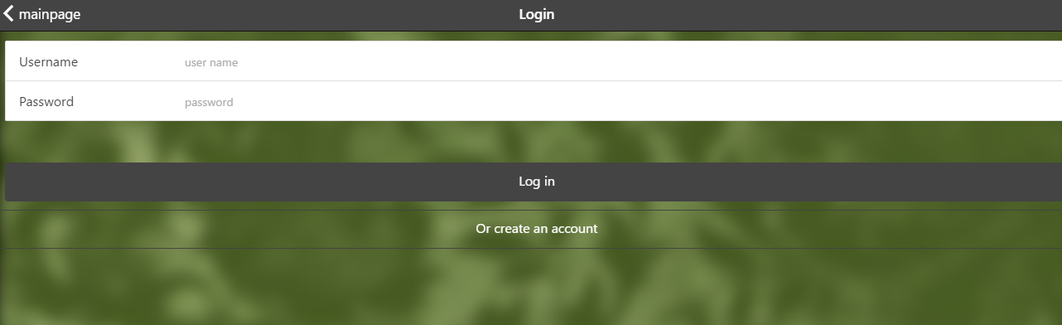

**Web-Ionic Signup page screen shot:**

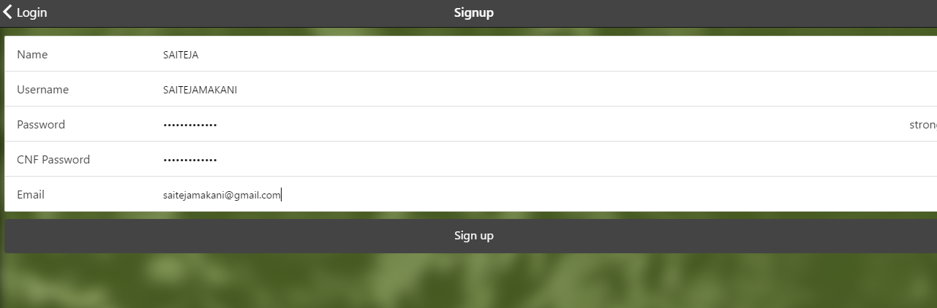

**Web-Ionic BarCode page screen shot:**

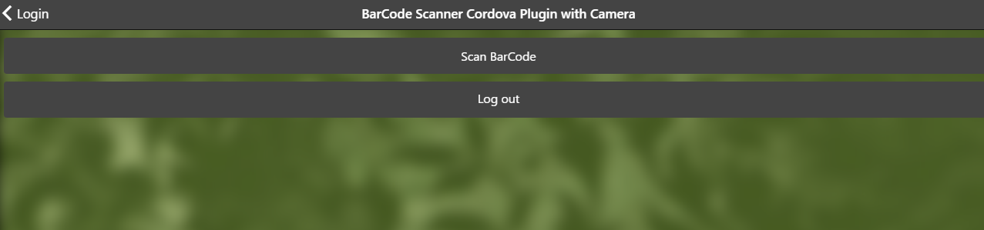

**Ionic Mobile app Main page:**

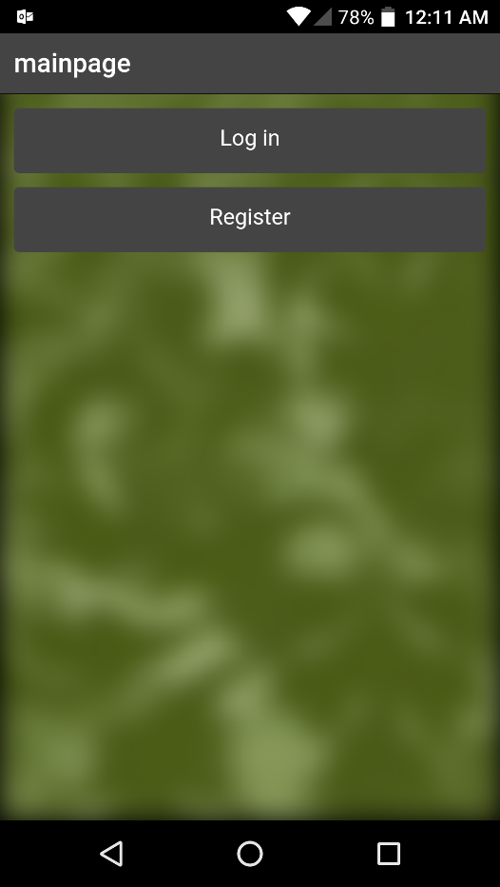

**Ionic Mobile app Login Page screenshot:**

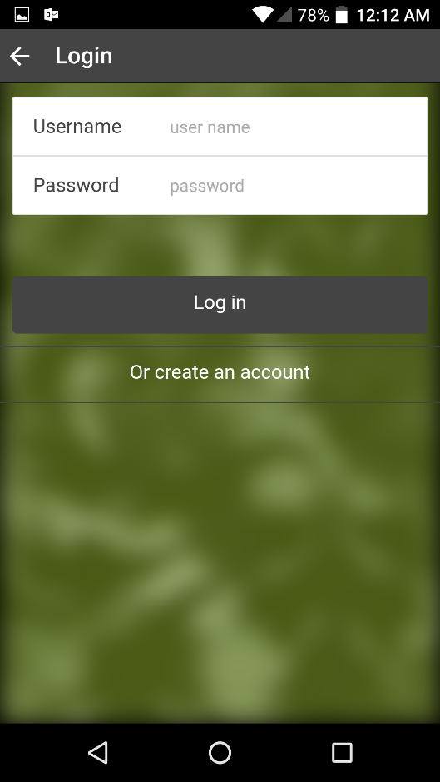

**Ionic Sign up Mobile App screenshot:**

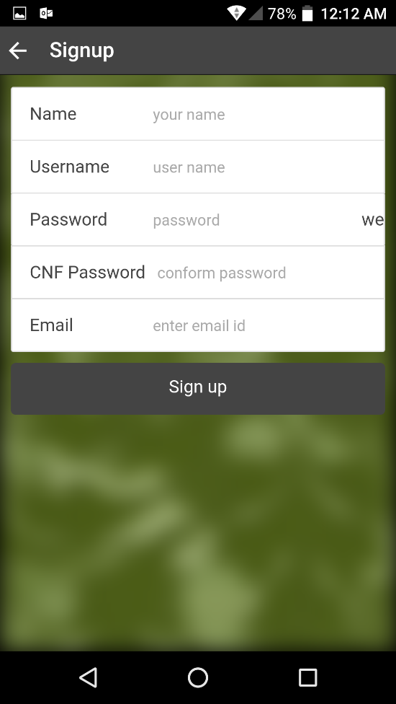

**Ionic Mobile app home page:**

on clicking Scan Barcode camera will turn on reads the barcdoe in view finder.

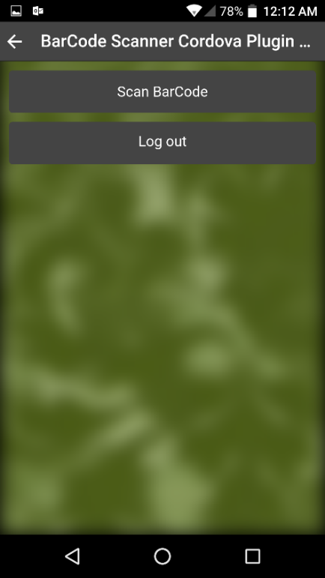

**Ionic Screen shots of barcode scanner scanning a barcode:**

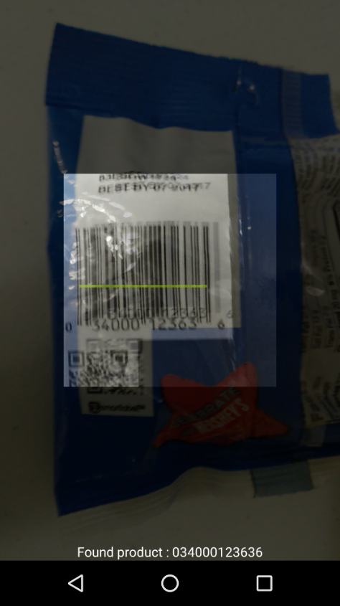 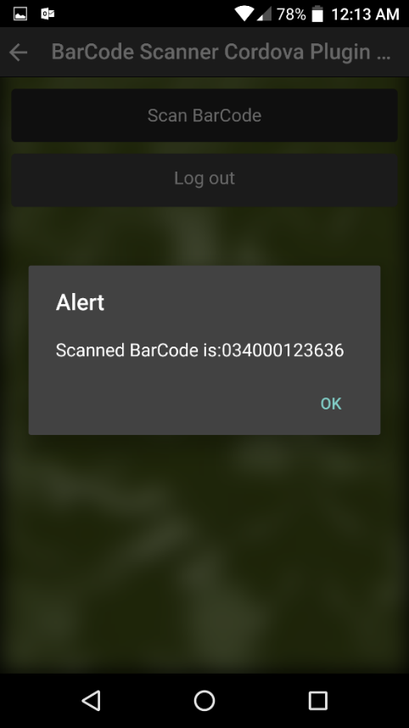

**Ionic Screen shots of barcode scanner scanning a QRCode:**

All the readable formats of the bar code are listed at the end of the document and barcode scanner plugin details are also listed.

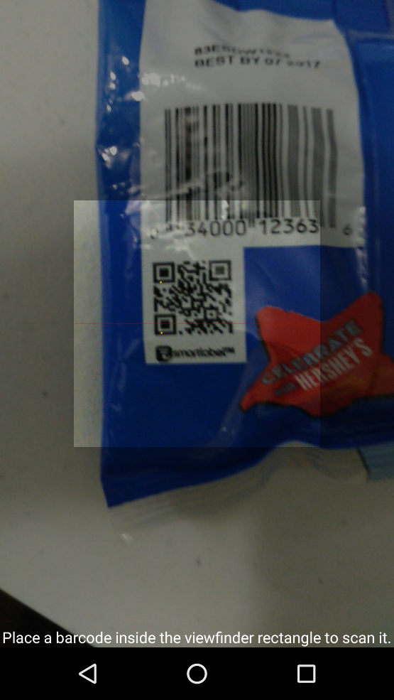 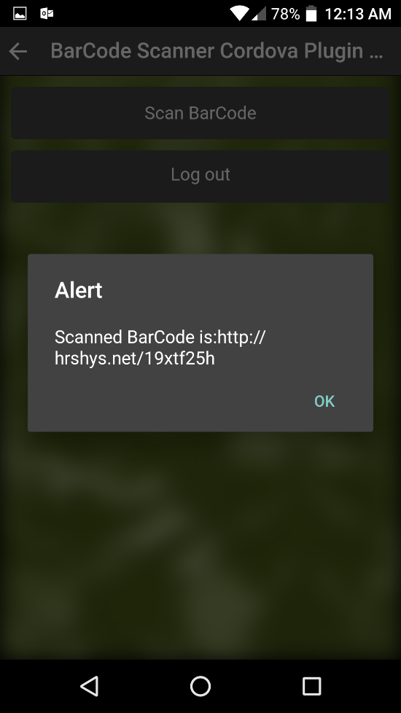

**Karma Unit Testing Screenshots are attached:** controller which is tested on karma is given below.

=================================================

lab7.controller('PasswordController', function PasswordController($scope) {

$scope.password = '';

$scope.grade = function() {

var size = $scope.password.length;

if (size > 8) {

$scope.strength = 'strong';

} else if (size > 3) {

$scope.strength = 'medium';

} else {

$scope.strength = 'weak';

}

console.log("password length::" +size +" Strength:" + $scope.strength);

};

})

==========================================================

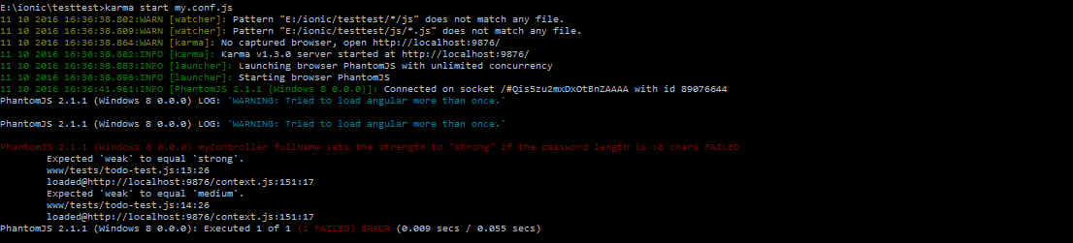

**Yslow Performance Testing Details are attached below:**

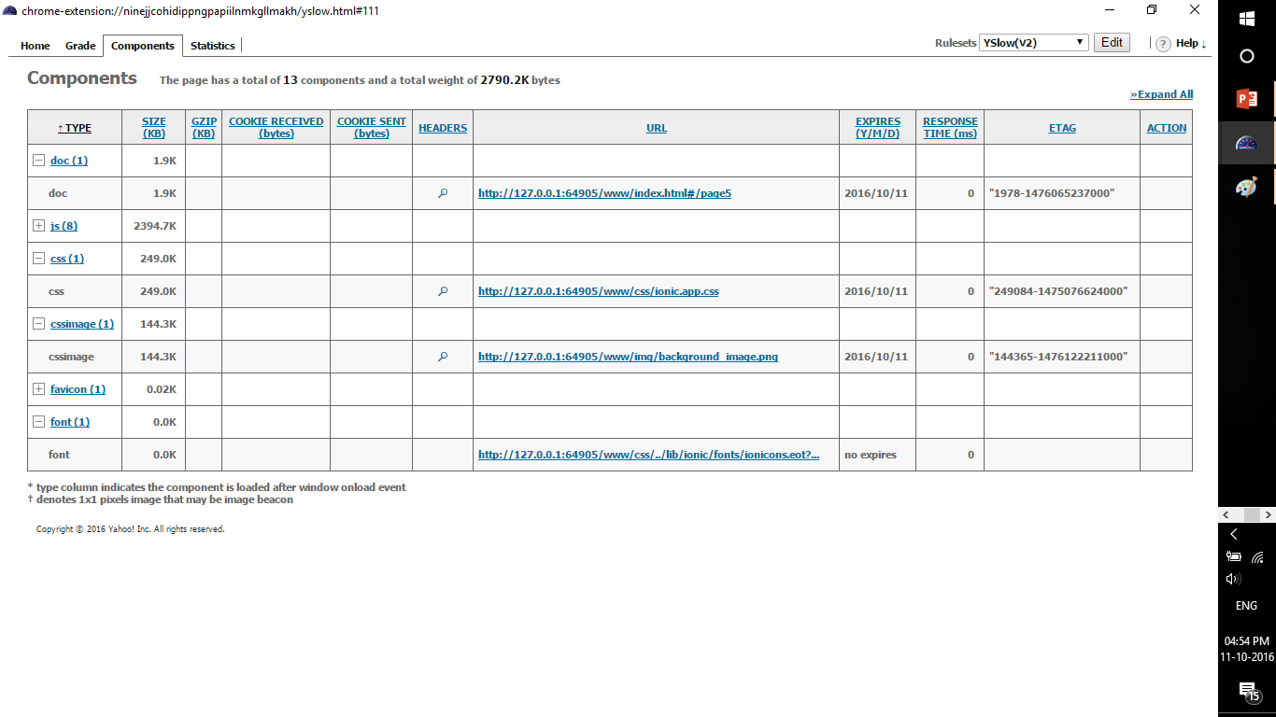

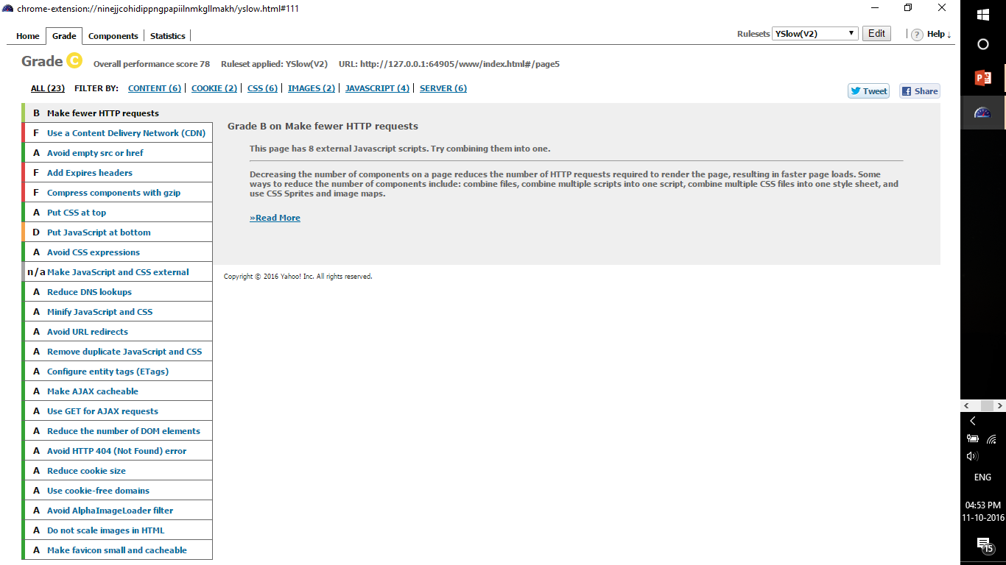

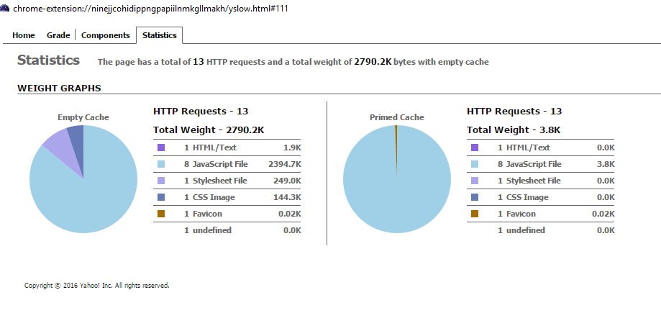

**Cordova plugin details:**

**http://ngcordova.com/docs/plugins/barcodeScanner/**

**https://www.thepolyglotdeveloper.com/2014/09/implement-barcode-scanner-using-ionic-framework/**

**Readable code formats of barcode scanner are:**

**QR Code**

**Data Matrix**

**UPC E**

**UPC A**

**EAN 8**

**EAN 13**

**Code 128**

**Code 39**